Message
from

Her Excellency the Honourable Kerry Sanderson, AO
Governor of Western Australia

For
Western Australian Men’s Shed Conference
Monday, 21 September 2015

I am very pleased to have been invited to officially open the fifth Western Australian Men’s Shed Conference. There has been a large increase in the number of Men’s Sheds in Western Australia since the first conference was organised by the Mukinbudin Men’s Shed in 2009.

Probably the simplest and most important benefit that Men’s Sheds provide for your members is social contact. The opportunity to engage in creative pursuits is particularly important for men who are not in the workforce.

The total environment of the Men’s Shed promotes health and wellbeing. I understand that you undertake considerable health promotion via fact sheets and guest speakers.

Men’s Sheds can also assist in overcoming social isolation for men suffering from mental illness, Alzheimer’s Disease and a wide range of other health issues.

I am fascinated by Men’s Sheds being established in Karnet Prison and a BHP mining camp and pleased to learn of the increased number of Sheds operating from retirement villages.

The impact of Men’s Sheds through the provision of social infrastructure and their contribution to community development is even greater in regional and country areas than it is in the metropolitan area. Men’s Sheds throughout the state are actively involved in providing support to local community groups.

Government agencies and other service providers are using Men’s Sheds to access a group in the community to which they have often had little success in delivering information and services.

I wish to compliment Lotterywest for assisting so many country delegates to attend the conference. I also wish to acknowledge the sponsors, trade exhibitors and NGOs that are supporting this conference.

I wish you all the best today and for your ongoing valuable contribution to men, their families and communities.

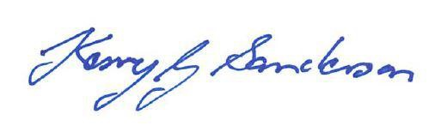

GOVERNOR

